**实验四**

**姓名：余洋 班级：计科2201班 学号：6020222510**

**实验名称：选择结构程序设计**

**一实验目的**

1. **了解使用c语言表示逻辑真和假的方法**
2. **掌握关系运算符和关系表达式、逻辑运算符和逻辑表达式的使用方法**
3. **掌握if语句和switch语句的使用方法。**

**二实验内容**

**1**

**#include <stdio.h>**

**int main()**

**{**

**char ch;**

**scanf("%c",&ch);**

**if(ch>='0'&&ch<='9')**

**printf("ch为数字:\n");**

**else if(ch>='a'&&ch<='z')**

**printf("ch为字母:\n");**

**else printf("ch为其他字符:\n");**

**return 0;**

**}**

**运行程序如图**

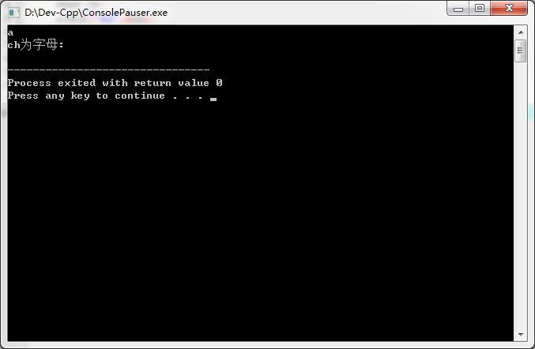

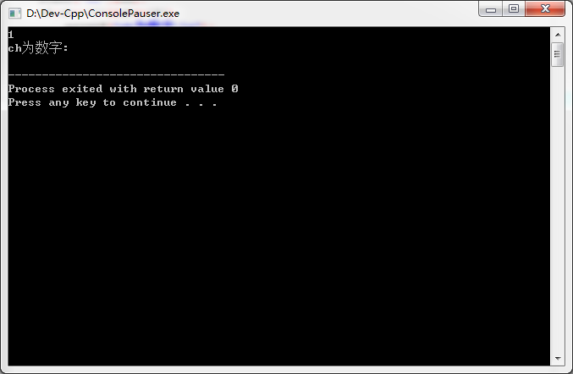

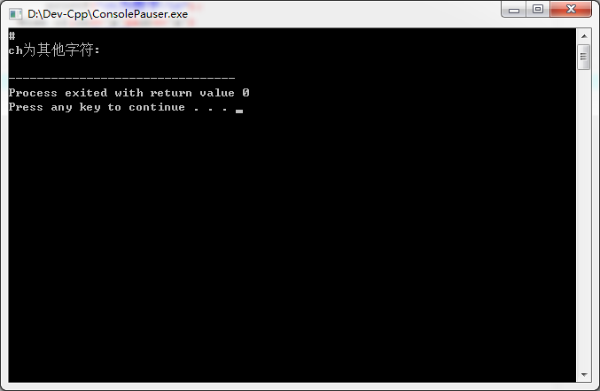

**2，#include <stdio.h>**

**int main()**

**{**

**int a;**

**scanf("%d",&a);**

**if(a%2==0)**

**printf("a为偶数:\n");**

**else**

**printf("a为奇数:\n");**

**return 0;**

**}**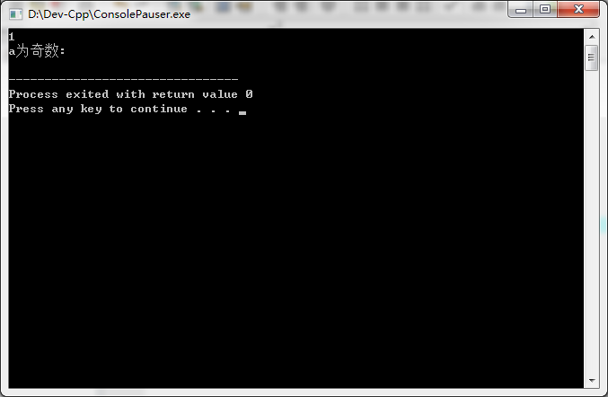

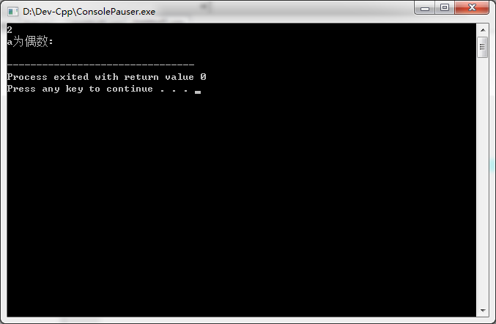

**3，**

**#include <stdio.h>**

**int main()**

**{**

**float speed;**

**scanf("%f",&speed);**

**if(speed>60)**

**printf("Speed-速度值Speeding:\n");**

**else**

**printf("Speed-速度值OK:\n");**

**return 0;**

**}**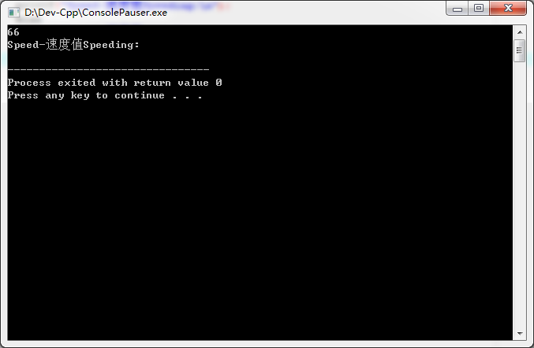

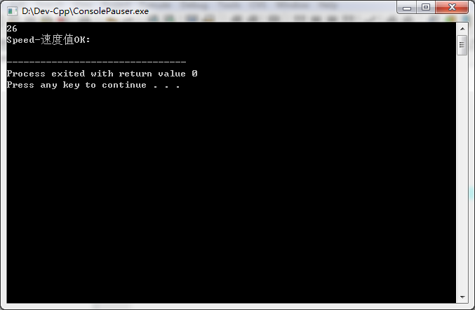

**4，**

**#include <stdio.h>**

**#include <math.h>**

**int main()**

**{**

**double x,y;**

**scanf("%lf",&x);**

**if(x<-1)**

**y=pow(x,3)-1;**

**else if(x>=-1&&x<=1)**

**y=-3*x+1;**

**else if(x>=1&&x<=10)**

**y=3*exp(2*x-1)+5;**

**else**

**y=5*x+3*log10(2*pow(x,2)-1)-13;**

**printf("%lf",y);**

**return 0;**

**}**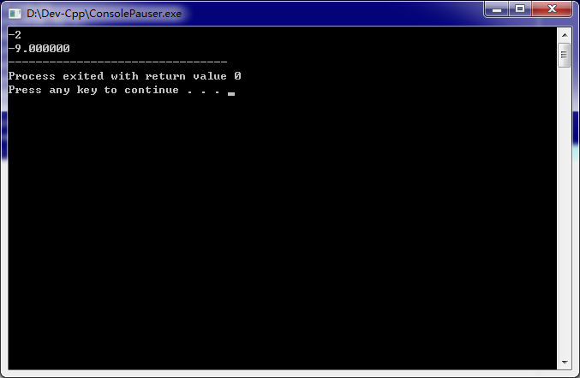

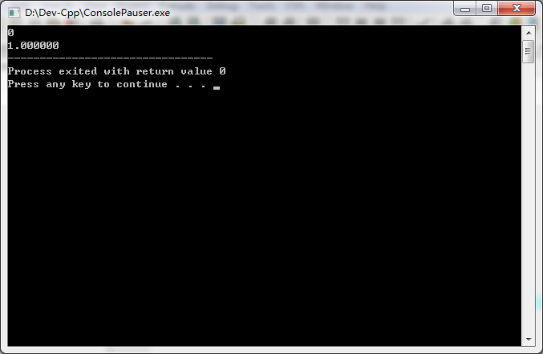

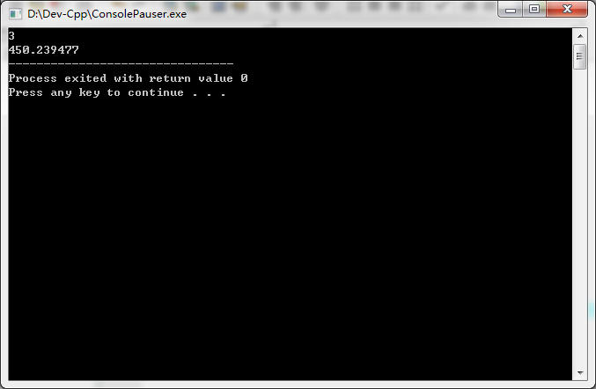

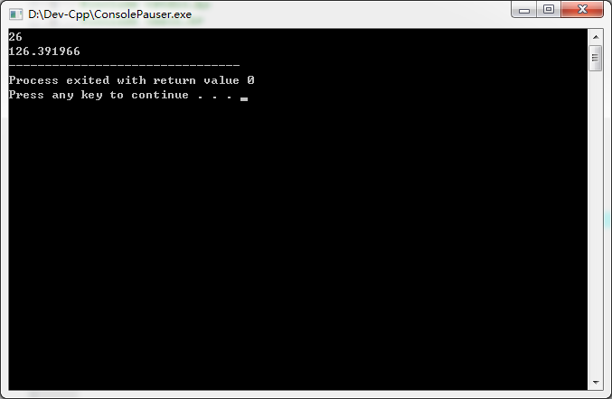

**5，**

**#include <stdio.h>**

**#include <math.h>**

**int main()**

**{**

**double a,b,c,area,s;**

**scanf("%lf%lf%lf",&a,&b,&c);**

**s=(a+b+c)/2;**

**if(a+b>c&&a+c>b&&b+c>a){**

**area=pow(s*(s-a)*(s-b)*(s-c),1/2);**

**printf("%lf",&area);**

**}**

**else**

**printf("ERROR:\n");**

**return 0;**

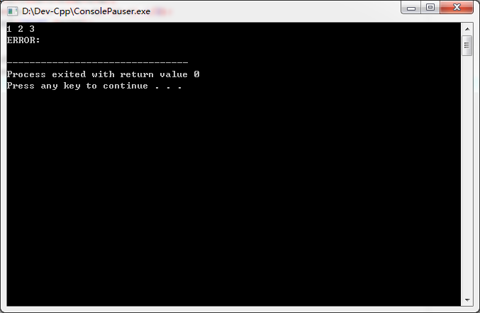

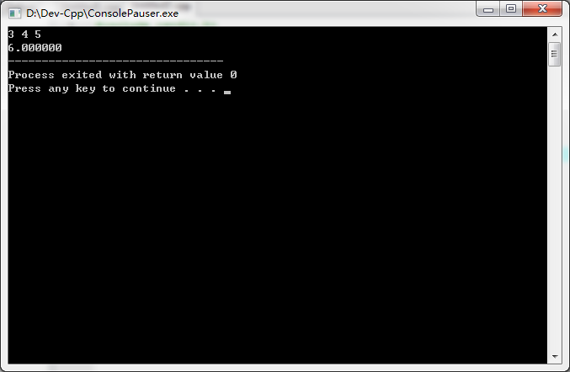

**#include <stdio.h>**

**#include <math.h>**

**int main()**

**{**

**int year;**

**scanf("%d",year);**

**if(year%4=0&&year%100!=0)**

**printf("闰年:\n");**

**else**

**printf("不是闰年:\n");**

**return 0;**

**}**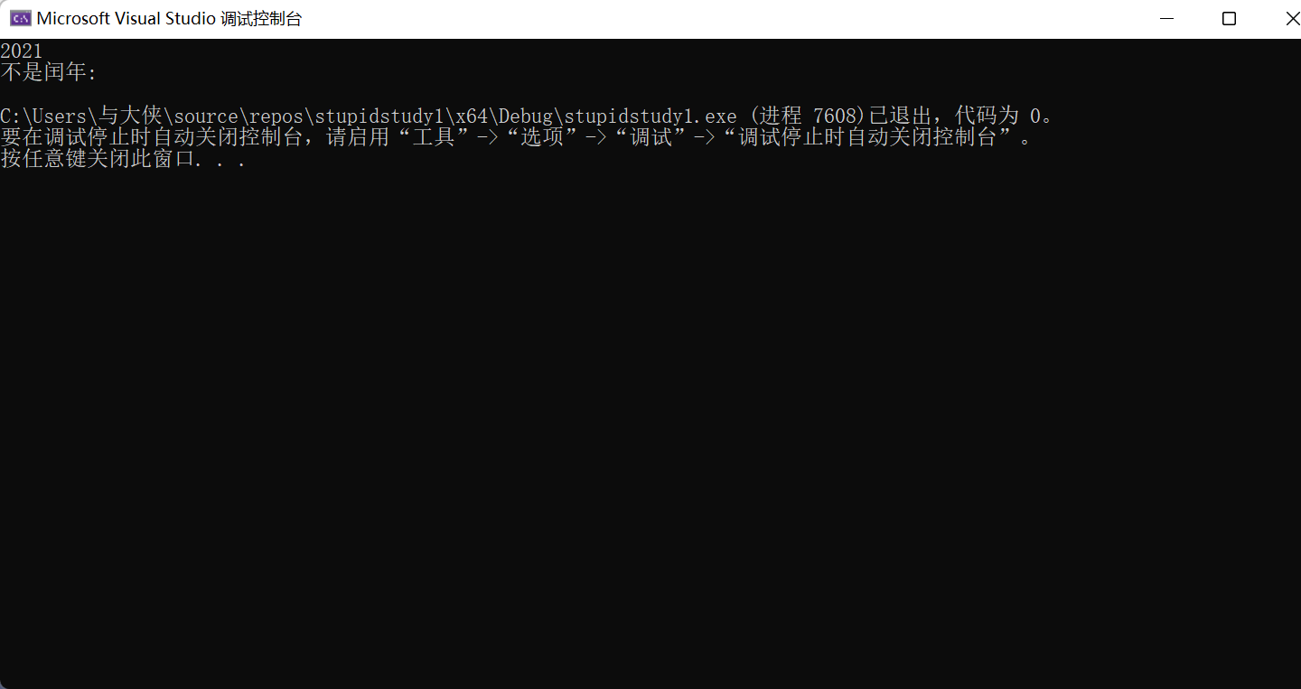

**7，**#include <stdio.h>

int main()

{

int a;

double price;

scanf_s("%d", &a);

if (a <= 50)

price = a * 0.53;

else

price = (a - 50) * 0.58 + 50 * 0.53;

printf("%lf", price);

return 0;

}

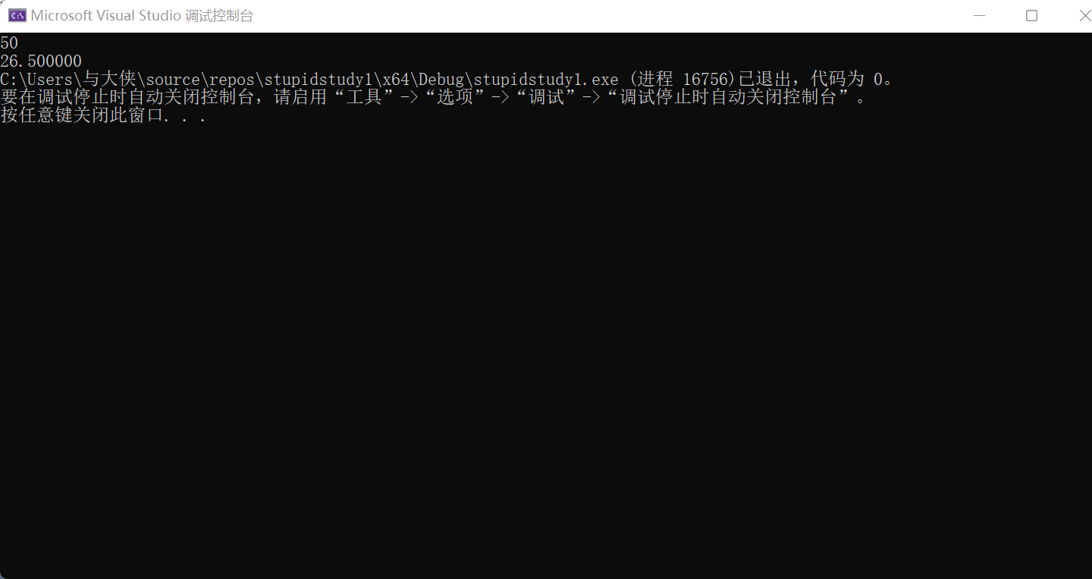

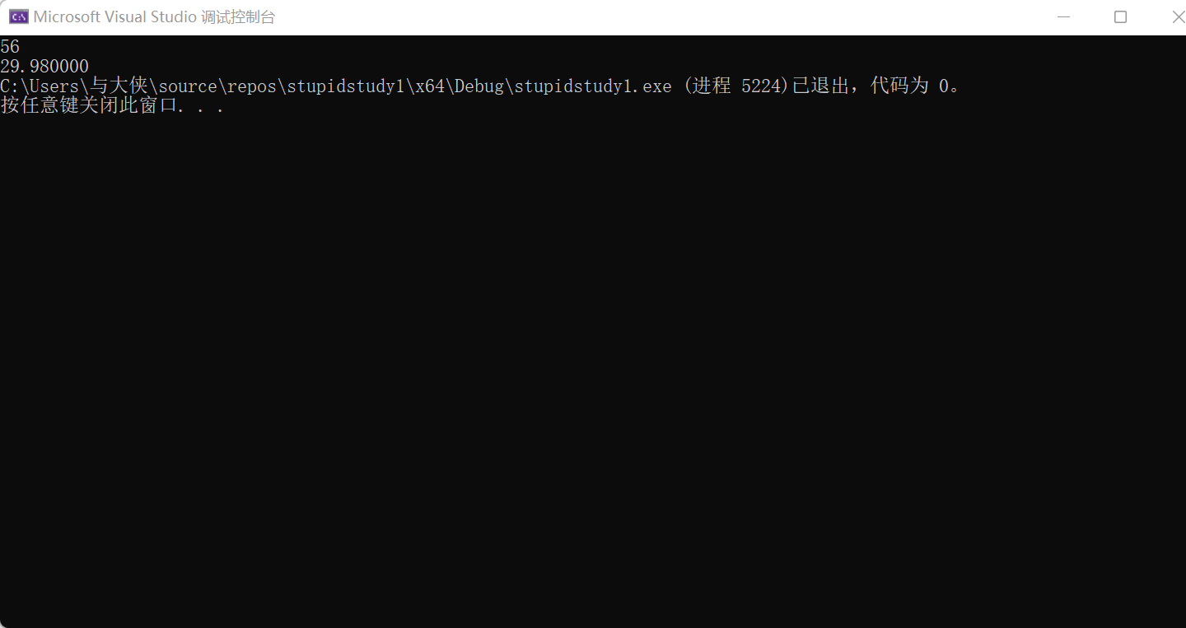

8，

#include <stdio.h>

int main()

{

double a, b, c;

scanf_s("%lf%lf%lf", &a, &b, &c);

if (a + b > c && a + c > b && b + c > a)

{

if (a == b || a == c || b == c)

printf("等腰三角形\n");

else if (a == b && b == c)

printf("等边三角形\n");

else printf("不等边三角形\n");

}

else

printf("ERROR!");

return 0;

}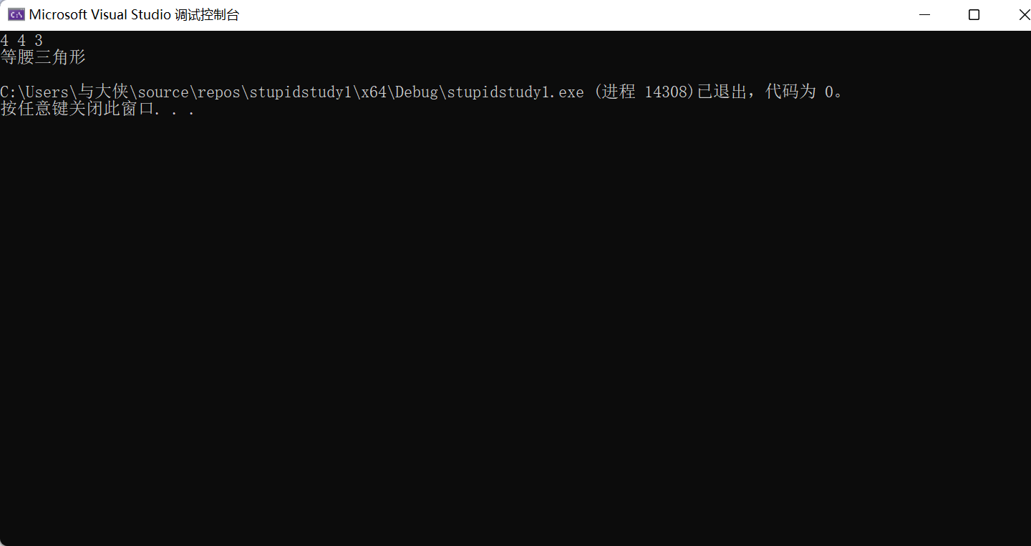

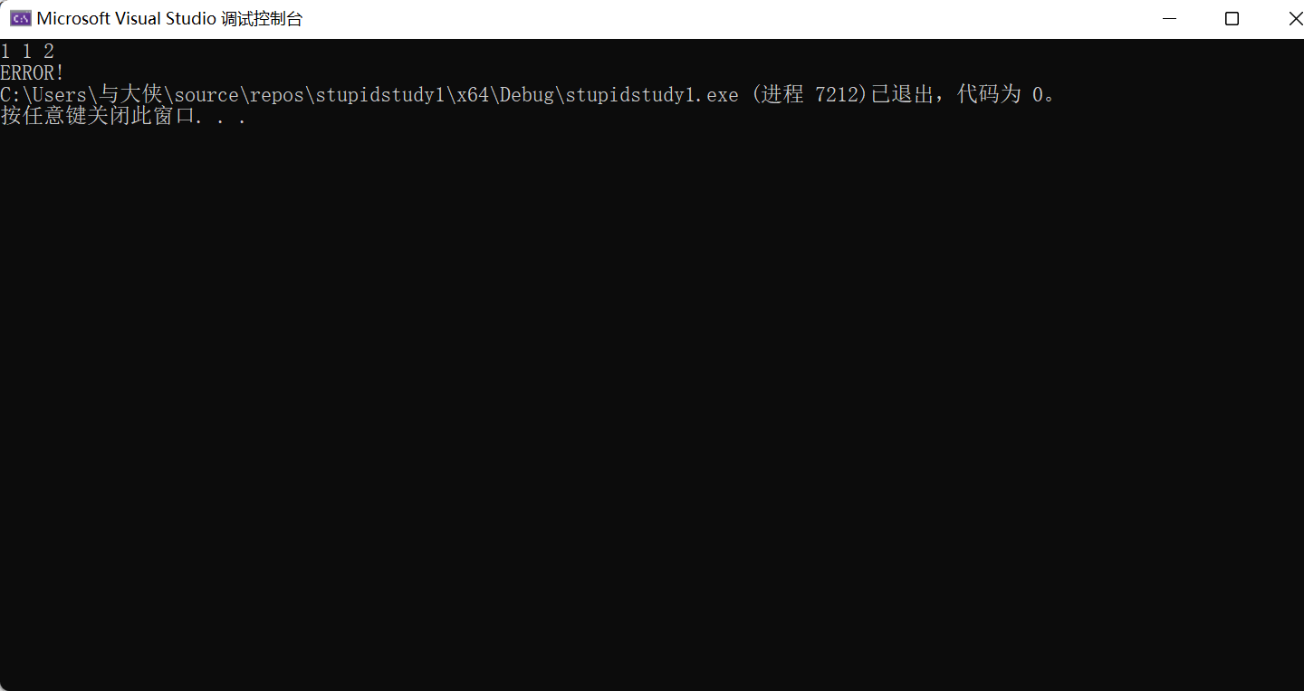

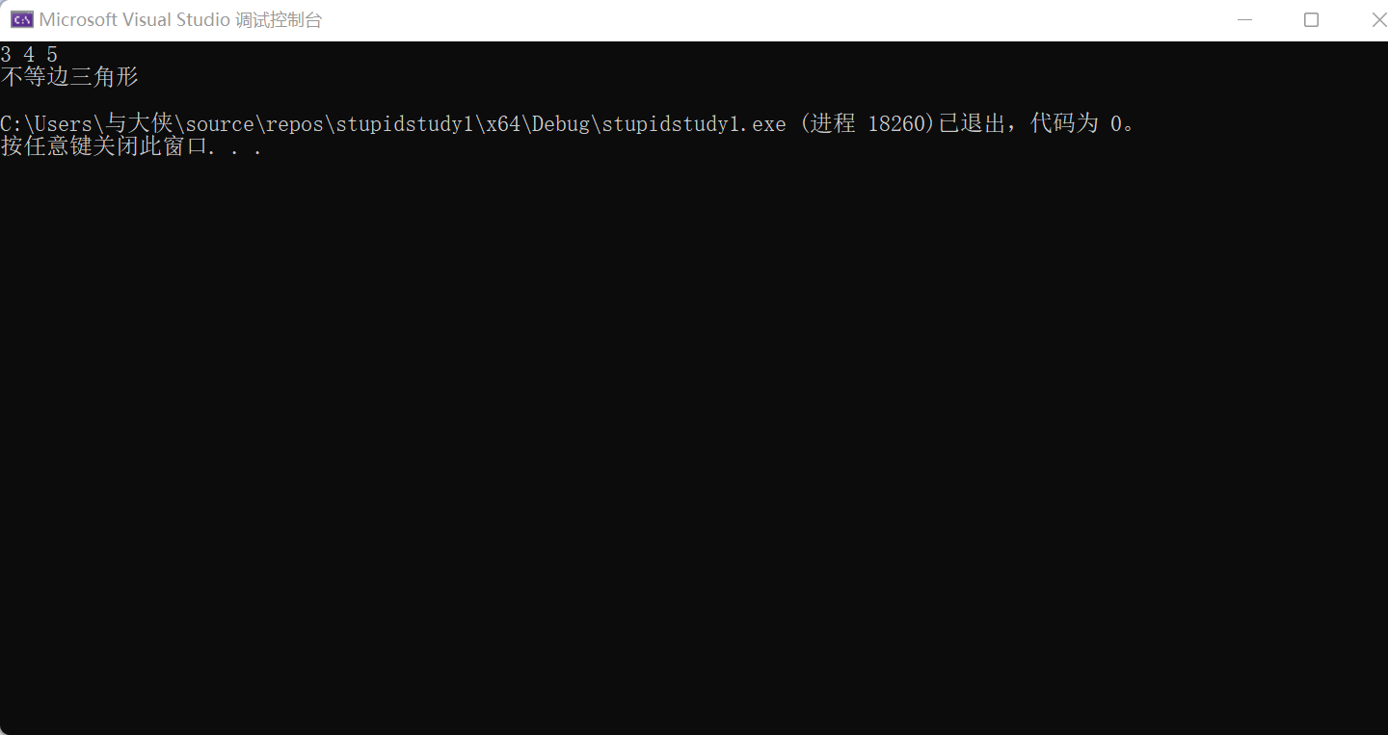

9，

#include <stdio.h>

int main()

{

int a;

scanf_s("%d", &a);

switch (a)

{

case 1:printf("Good morning"); break;

case 2:printf("Good afternoon"); break;

case 3:printf("Good evening"); break;

case 4:printf("Good might"); break;

default:printf("Bye-bye");

}

return 0;

}

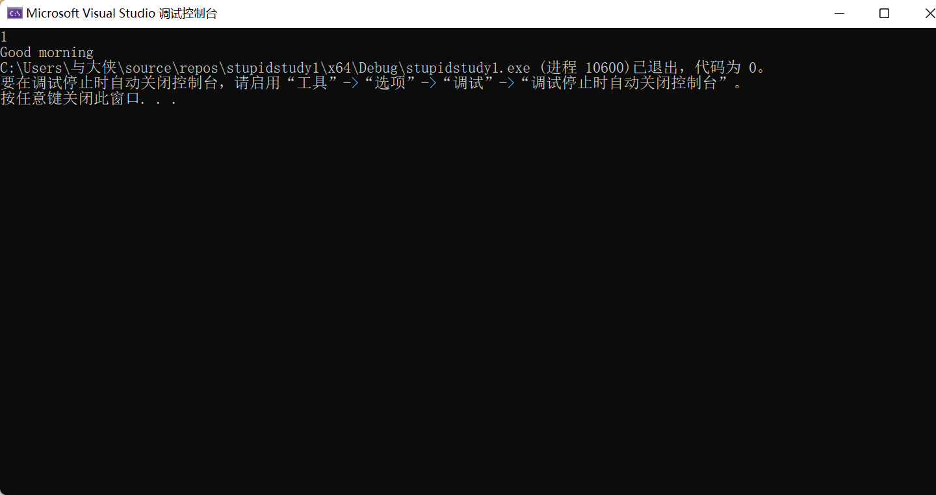

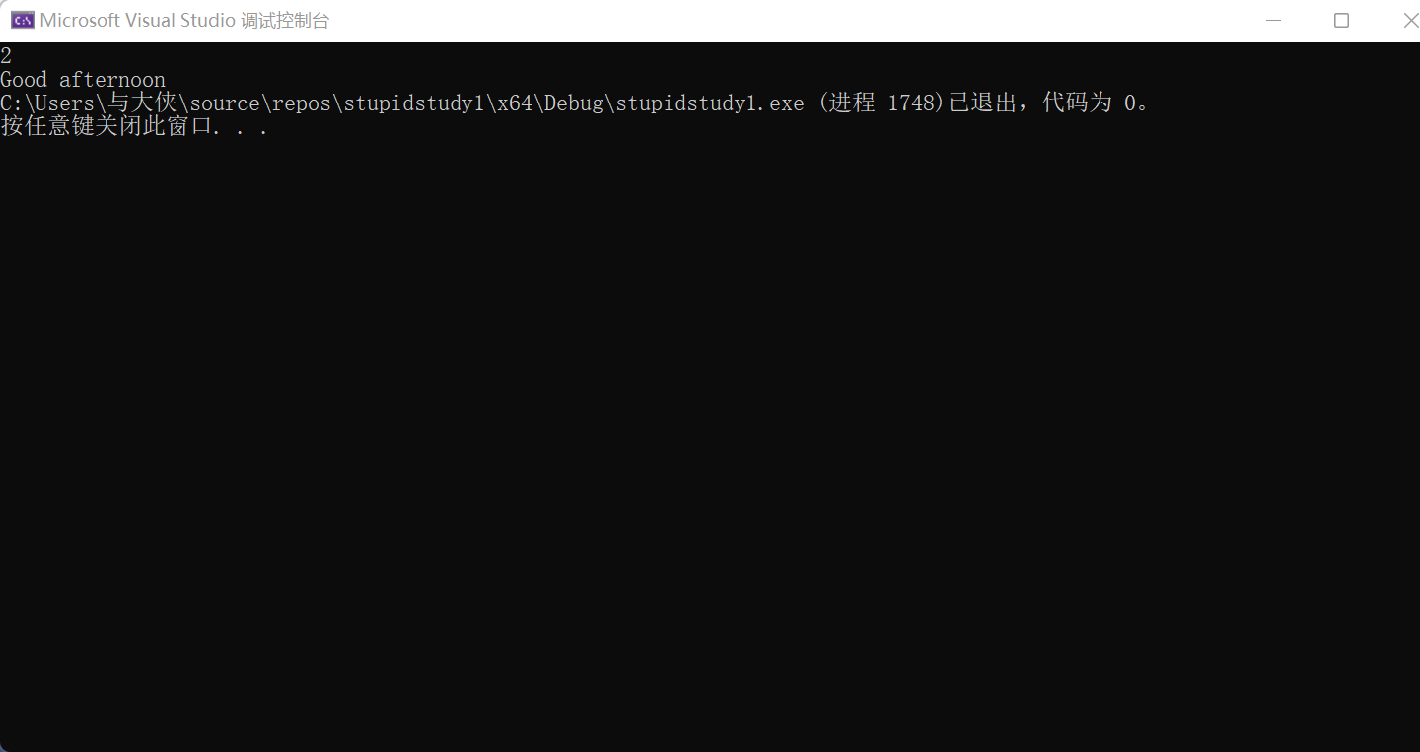

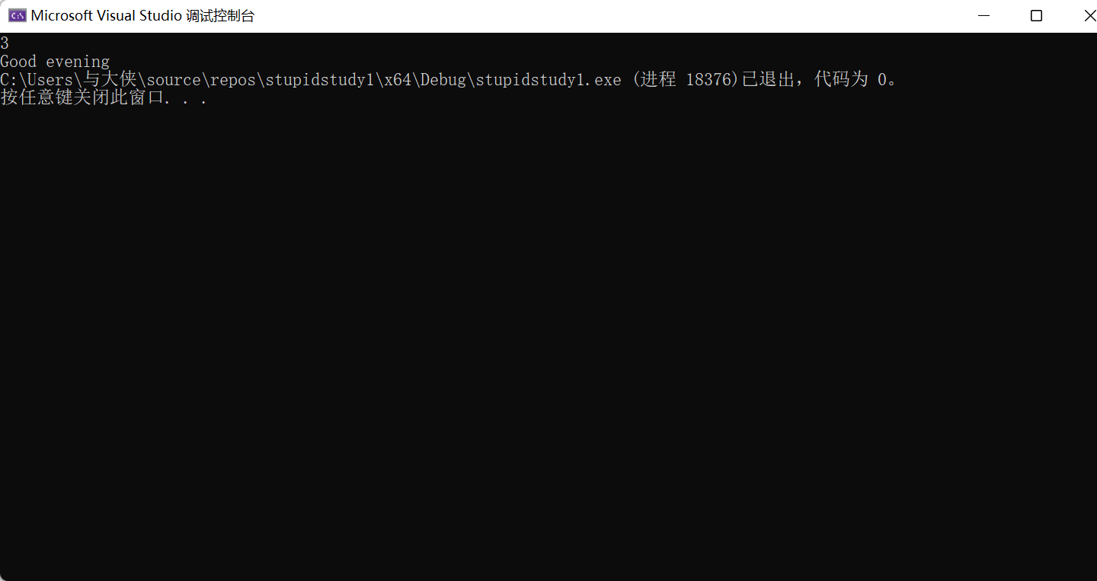

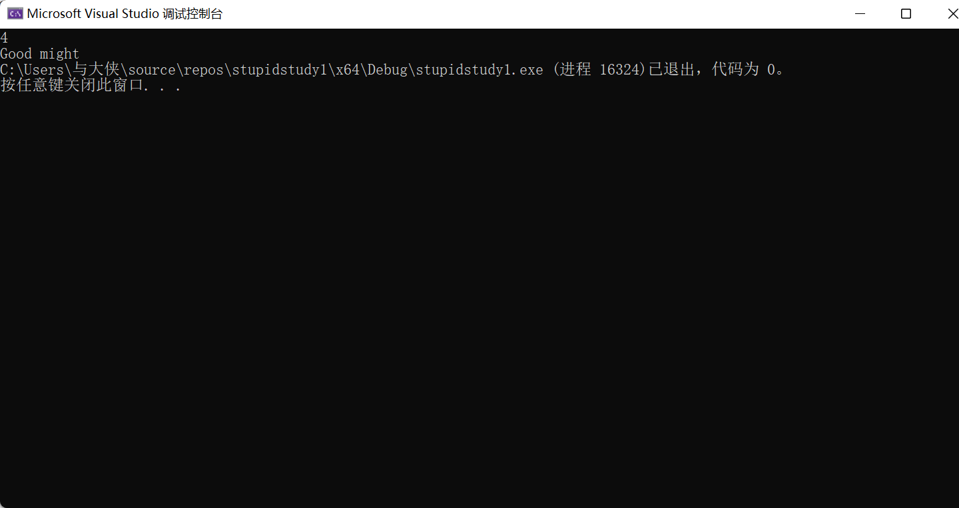

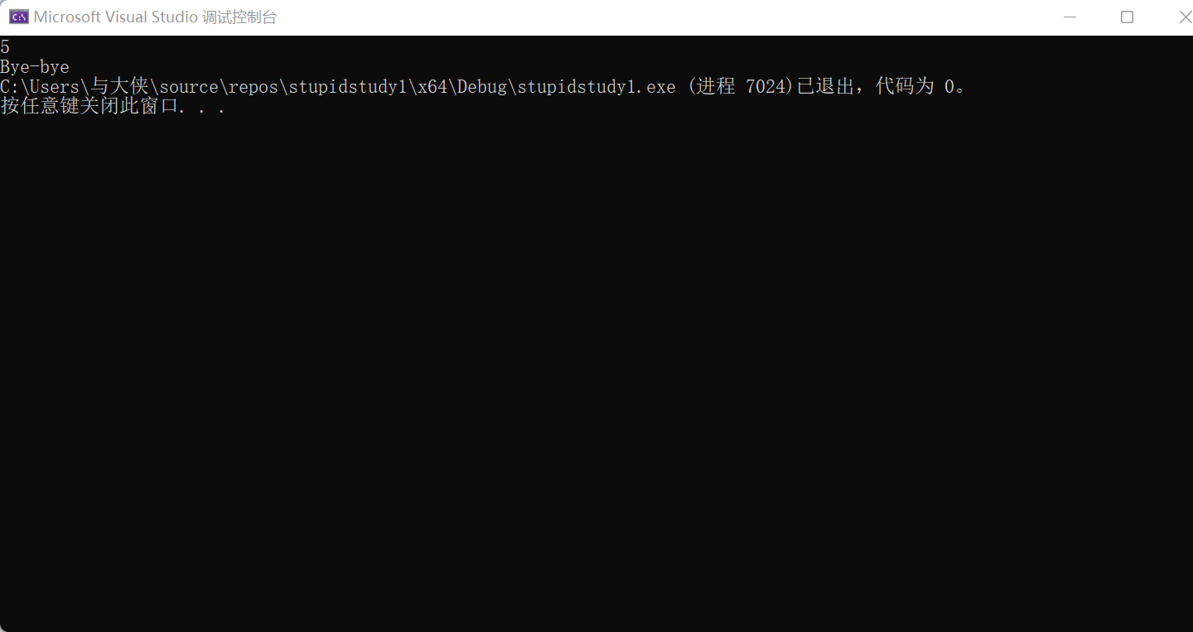

10#include <stdio.h>

int c1, c2, c3;

void fun(long n)

{

c1 = c2 = c3 = 0;

while (n) {

switch (n % 10)

{

case 1:c1++; break;

case 2:c2++; break;

case 3:c3++;

}

n /= 10;

}

}

main()

{

long n = 123114350L;

fun(n);

printf("\nThe result :\n");

printf("n=%ld c1=%d c2=%d c3=%d\n", n, c1, c2, c3);

}

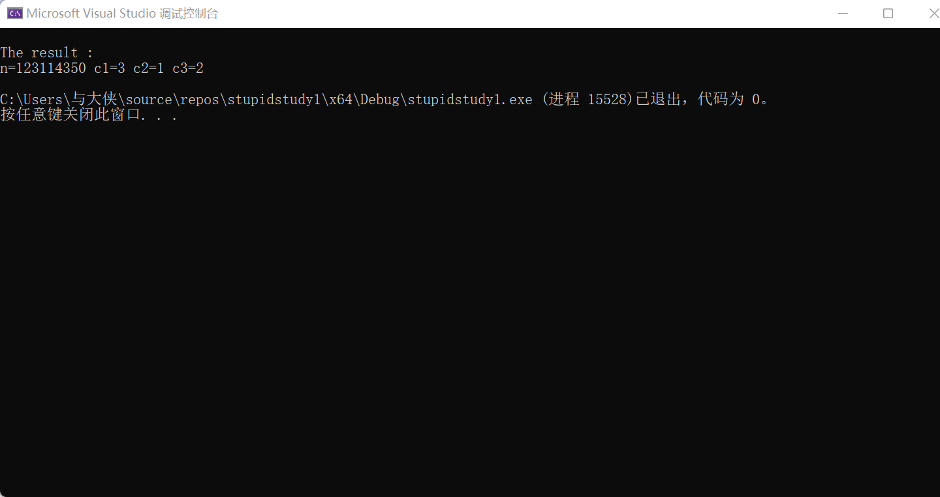

11,

#include <stdio.h>

int main()

{

int money,a;

double price;

scanf_s("%d%d", &money,&a);

if (a<= 12)

price = money + money * 0.009*a;

if (a> 12 && a <= 24)

price = money + money * 0.001 * a;

else if (a> 24 && a<= 36)

price = money + money * 0.0011 *a;

else

price = money + money * 0.0012 * a;

printf("%lf", price);

return 0;

}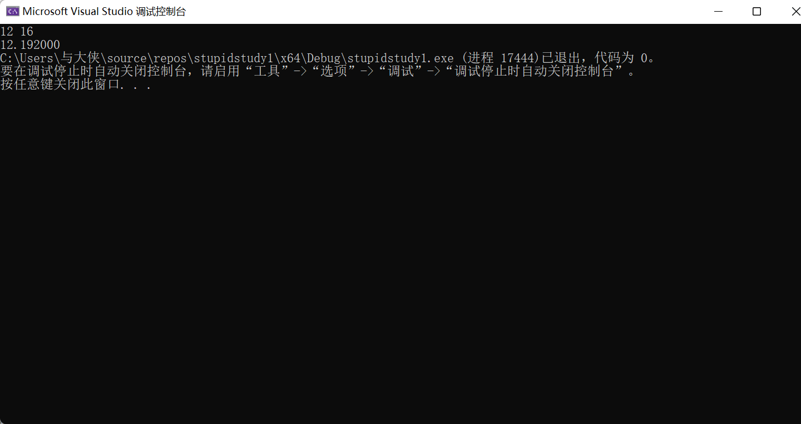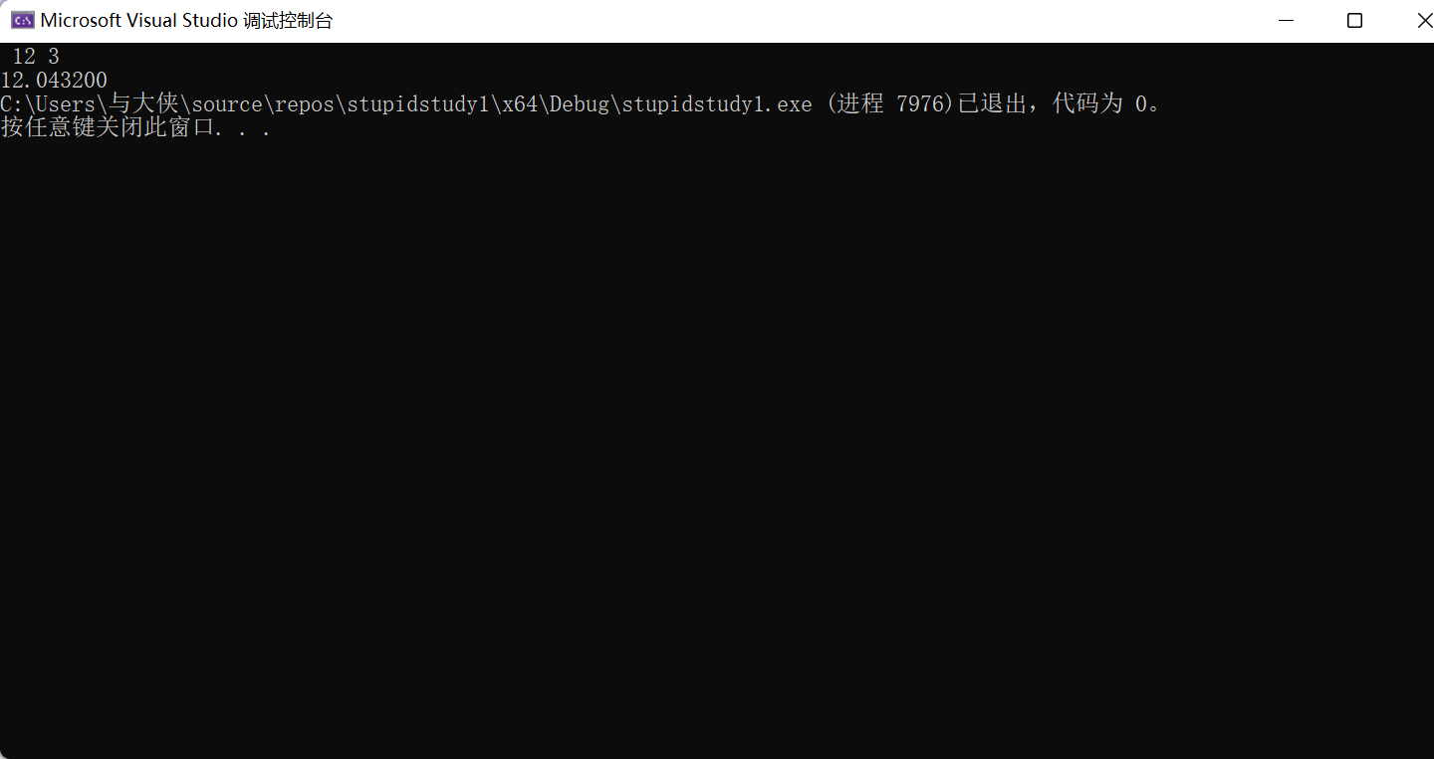





三，实验小结

1. 程序的输入输出格式依然要注意，且应该作为重点检查对象。
2. Ifelse的嵌套结构的书写要注意{}的添加是否得当，这对程序运行有极大的影响。

3，要尽可能的简化程序，让代码具有可读性。